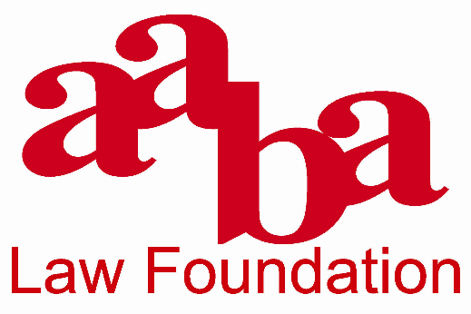

2019-2020 SCHOLARSHIP APPLICATION

The Asian American Bar Association of the Greater Chicago Area Law Foundation (“AABA Law Foundation”) was established in February 2009, and is a non-profit, charitable and educational affiliate of AABA that is tax-exempt under Internal Revenue Code Section 501(c)(3). The AABA Law Foundation engages in activities toward the following goals: (a) provide financial assistance to Asian Pacific American law students who have demonstrated academic excellence and social leadership; (b) support the development of internships and fellowships in the area of public interest and community service relating to the Chicago-area Asian Pacific American community; (c) assist in conducting legal scholarship and education with respect to legal issues affecting the Chicago-area Asian Pacific American community; and (d) develop and support programs to educate the legal profession and Asian Pacific American communities in the Chicago-area regarding legal issues affecting those communities.
As part of achieving its goals, each year the AABA Law Foundation awards scholarships to law students who have demonstrated a commitment to serving the needs of the Asian Pacific American community, and who will continue to serve the needs of the Asian Pacific American community through pro bono, public interest, and/or public service legal work. A connection to the Chicago area is preferred. This year, the AABA Law Foundation intends to award at least one scholarship of $5,000 to a law student who has exemplified that commitment, as well as one or more fellowships to support internships at local nonprofit organizations.
2019-2020 SCHOLARSHIP APPLICATION INSTRUCTIONS

In order to apply for the AABA Law Foundation’s Scholarship, please submit the attached application as well as the following materials:

Your resume;

A copy of your most recent law school transcript;

Two (2) letters of recommendations (from persons not related to you);

An essay (not to exceed 500 words) explaining how you have demonstrated a commitment to serve the needs of the Asian Pacific American community, how you plan to serve the needs of the Chicago-area Asian Pacific American community in the future; and

(Optional) A copy of your application to your law school for financial assistance.

Please submit the application and all supporting materials by May 1, 2020, to the AABA Law Foundation by e-mail at foundation@aabachicago.org or by mail to:
The AABA Law Foundation
c/o Stephen Y. Wu
McDermott Will & Emery LLP
444 West Lake Street, Suite 4000
Chicago, IL 60606

Please note that if you do not submit all required information, your application will not be considered by the AABA Law Foundation. For questions or more information, please contact Stephen Y. Wu at 312-372-2000 or swu@mwe.com

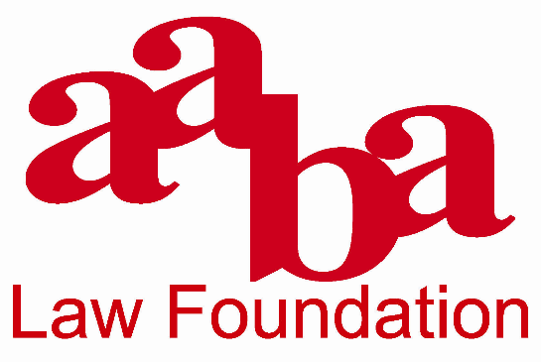

2019-2020 SCHOLARSHIP APPLICATION
NAME:
SCHOOL ADDRESS:
PERMANENT ADDRESS:
PHONE NUMBER: |  | Home |  |  |  |  | Cell
E-MAIL:
LAW SCHOOL NAME:
LAW SCHOOL ADDRESS:
EXPECTED YEAR OF GRADUATION:
ARE YOU THE FIRST PERSON IN YOUR IMMEDIATE FAMILY TO ATTEND LAW SCHOOL IN THE U.S.? |  |  |  |  |  | Yes No
I, the undersigned applicant, understand that if I am awarded an AABA Law Foundation Scholarship, I must be enrolled in good standing at least half-time in an ABA- or AALS-accredited law school as of May 1, 2020.
I understand that I must comply with all stated policies and conditions of the Scholarship, and that the funds awarded are to be used only for tuition, course-related expenses, or reasonable living expenses while enrolled in law school.
I understand that my failure to comply with all AABA Law Foundation policies and conditions of the Scholarship may result in the forfeiture of the entirety or a portion of the Scholarship award. In such event, I will return the entirety or required portion of the Scholarship monies to the AABA Law Foundation promptly upon written demand. Failure to return these monies may result in collection efforts and legal action against me. To the extent allowable by law, the recipient will be responsible for all costs, fees, and expenses incurred by the AABA Law Foundation in seeking recovery of the award monies.
I understand that officers and directors of AABA, the AABA Law Foundation, members of the Scholarship selection committee, and their immediate families are ineligible for the Scholarships. I also understand that all materials submitted to the AABA Law Foundation will become property of the AABA Law Foundation and that the AABA Law Foundation reserves the right to issue public announcements regarding Scholarship award winners and to publish their essays.
Pursuant to 28 USC 1746, I declare (or certify, verify or state) under penalty of perjury that all statements and information contained herein and in all application materials submitted by me are true, correct, and accurate to the best of my knowledge. I certify that the essay attached hereto was written solely by me and is my original work.
Signature of Applicant

Dated: |  | , | 20___

